Directions: The goal of the following problems is to help challenge and deepen your understanding of the current topic. Don’t assume that you will know how to answer every question. You will work with at least two other students in the class to try and find solutions and write arguments for each of the following questions. Be sure that you question your classmates’ reasoning. If you don’t understand how they are getting something, you should ASK THEM TO EXPLAIN! Being able to defend your reasoning is important and so you are actually helping them by asking them to explain.

Challenge Questions

- Consider the function . Note that without a calculator the value is difficult to determine.
- Create a degree 3 Maclaurin polynomial to model the function .

We want to find: .

We note that

Therefore, the 3rd degree Maclaurin polynomial is:

- Estimate the value of using each polynomial.

So

- Create a graph of the function and the approximating polynomial that you have built to model it. Feel free to use a graphing utility to assist with this.
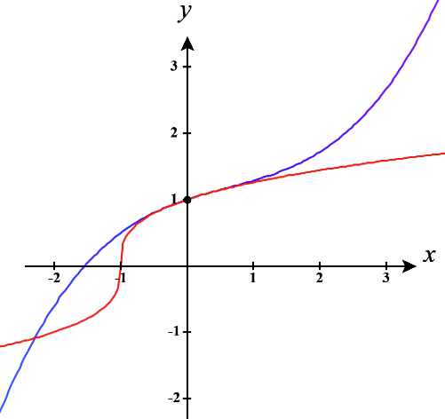

is in red.
is in blue.

- Based on your picture would expect to have overestimated or underestimated the value? How might you be able to create a better approximation for ?

We can see that our estimate of is going to be much larger than the actual value.
We could make our approximation better if we created a polynomial that was centered closer to OR we could create more terms in our polynomial.

- Create a Maclaurin polynomial of degree 2 for and use it to estimate the value of .
We want to find: and evaluate this polynomial at since .

We note that

Therefore, the 2nd degree Maclaurin polynomial is:
So

- Find the Taylor series for centered at .
We want to find: which means we need to determine.
We note that:
So we see, .
Therefore, the Taylor series is:

- Consider a function with values of its derivative at given by .
- Find the Taylor series for this function for centered at .

We want to find: and we are told that .
Therefore, the Taylor series is:

- Find the radius of convergence and interval of convergence of this Taylor series.

By the Ratio Test we see that

Therefore, the series will converge if .
Therefore, the Radius of Convergence is .

We now look at the behavior at each of the endpoints.
At we see that . This is the Harmonic Series and therefore diverges.

At we see that . This is the alternating Harmonic Series and therefore converges, by the AST.

So, the IOC for this power series is .

- The power series can be used to model the curve . Show how you can use the Ratio Test to determine the interval and radius of convergence for this power series.

By the Ratio Test we see that

Therefore, the series will converge if .
Therefore, the Radius of Convergence is .

We now look at the behavior at each of the endpoints.
At we see that . This series diverges.

At we see that . This series diverges.
So, the IOC for this power series is .

- Suppose that converges for , but diverges for .
- What can you say about the convergence of at ? What about at ?

We can see that the power series is centered at .
We know there are only 3 possible ways a power series can converge:
- At a single point (represents where the power series is centered)
- In an interval centered around .
- At all values of x.
Since the series converges at the first option isn’t possible.
Since the series diverges at the third option isn’t possible.
So, must converge on an interval around . Based on the given information this interval is at smallest and at largest .
Therefore, must converge at and must diverge at .

- What can you say about the convergence of ?
This is the original series being evaluated when and since is within the IOC it must be the case that this series converges.

- What can you say about the convergence of ?
This is the original series being evaluated when and since is outside of the IOC it must be the case that this series diverges.

- Find a power series whose interval of converge is

We see that the power series need to be centered at and so we start with .
We see if then the series diverges by the Test for Divergence.
We see if then the series diverges by the Test for Divergence.

We start with and we need to make the series converge when , but diverge when .
Consider .
We see if then the series converges by the AST.
We see if then the series diverges because it is the Harmonic series.

We start with and we need to make the series diverge when , but converge when .
Consider .
We see if then the series diverges because it is the Harmonic series.
We see if then the series converges by the AST.

We start with and we need to make the series converge when , but converge when .
Consider .
We see if then the series converges by the AST.
We see if then the series converges because it is a p-series with .

